

Rex Odomero Oghenerobo

ASSIGNMENT REPORT GO-API
Understanding and customizing the codebase

CENTRIA UNIVERSITY OF APPLIED SCIENCES
Month Year (e.g. September 2021)

CONTENTS

1 INTRODUCTION 1
2 Technologies used 2
3 folder structure 3
4 AUTHENTICATION 4
5 API ENDPOINTS TESTED 5
5.1 POST /parking — Create a parking event 5
5.2 PUT /parking/1 — Update a parking event 5
5.3 GET /parking/all — List all events 6
5.4 DELETE /parking/delete/1 — Delete a parking event 6
6 UNIT TESTING 8
7 DATABASE VERIFICATION 9
8 CONCLUSION 10
REFERENCES 11

INTRODUCTION
This project implements a RESTful API for managing parking events using Go and SQLite. The system supports full CRUD operations, authentication, validation, and unit testing. The API was tested using Thunder Client in Visual Studio Code, and data was stored persistently in a local SQLite database (production.db).

Technologies used
- Go (Golang) for backend logic
- SQLite for data persistence
- Thunder Client for API testing
- VS Code SQLite Viewer for database inspection

folder structure
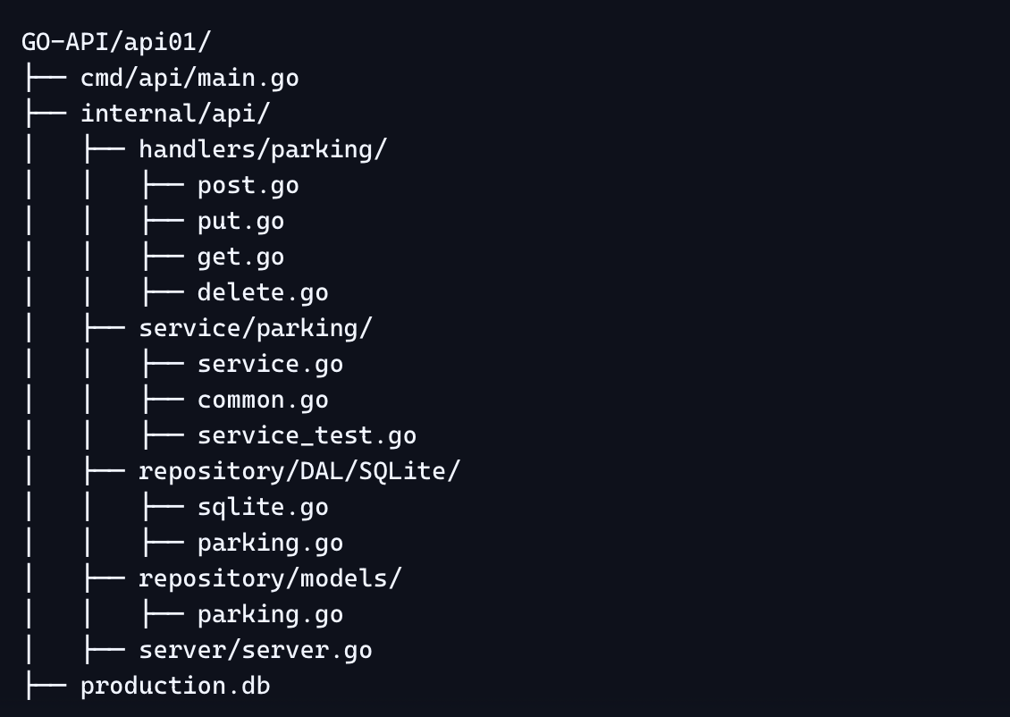…

AUTHENTICATION
All endpoints are protected using Basic Auth:
- Username: admin_oghenerobo
- Password: StrongPass!2025

API ENDPOINTS TESTED

POST /parking — Create a parking event
- Tested in Thunder Client
- Response: 201 Created
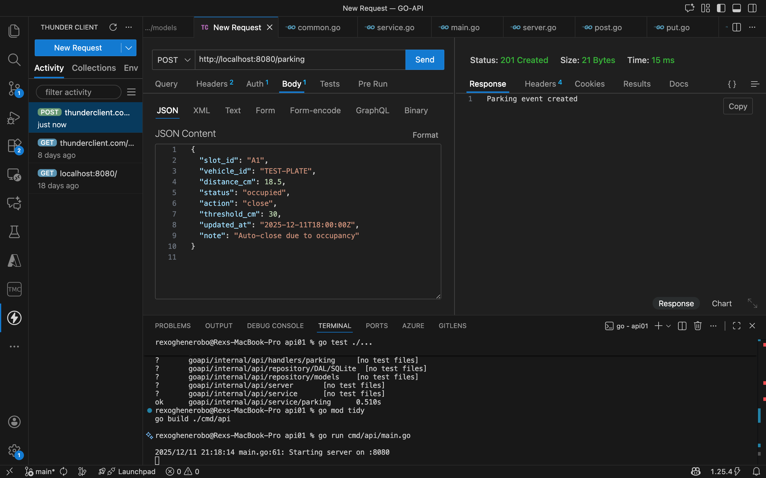

PUT /parking/1 — Update a parking event
- Tested in Thunder Client
- Response: 200 OK
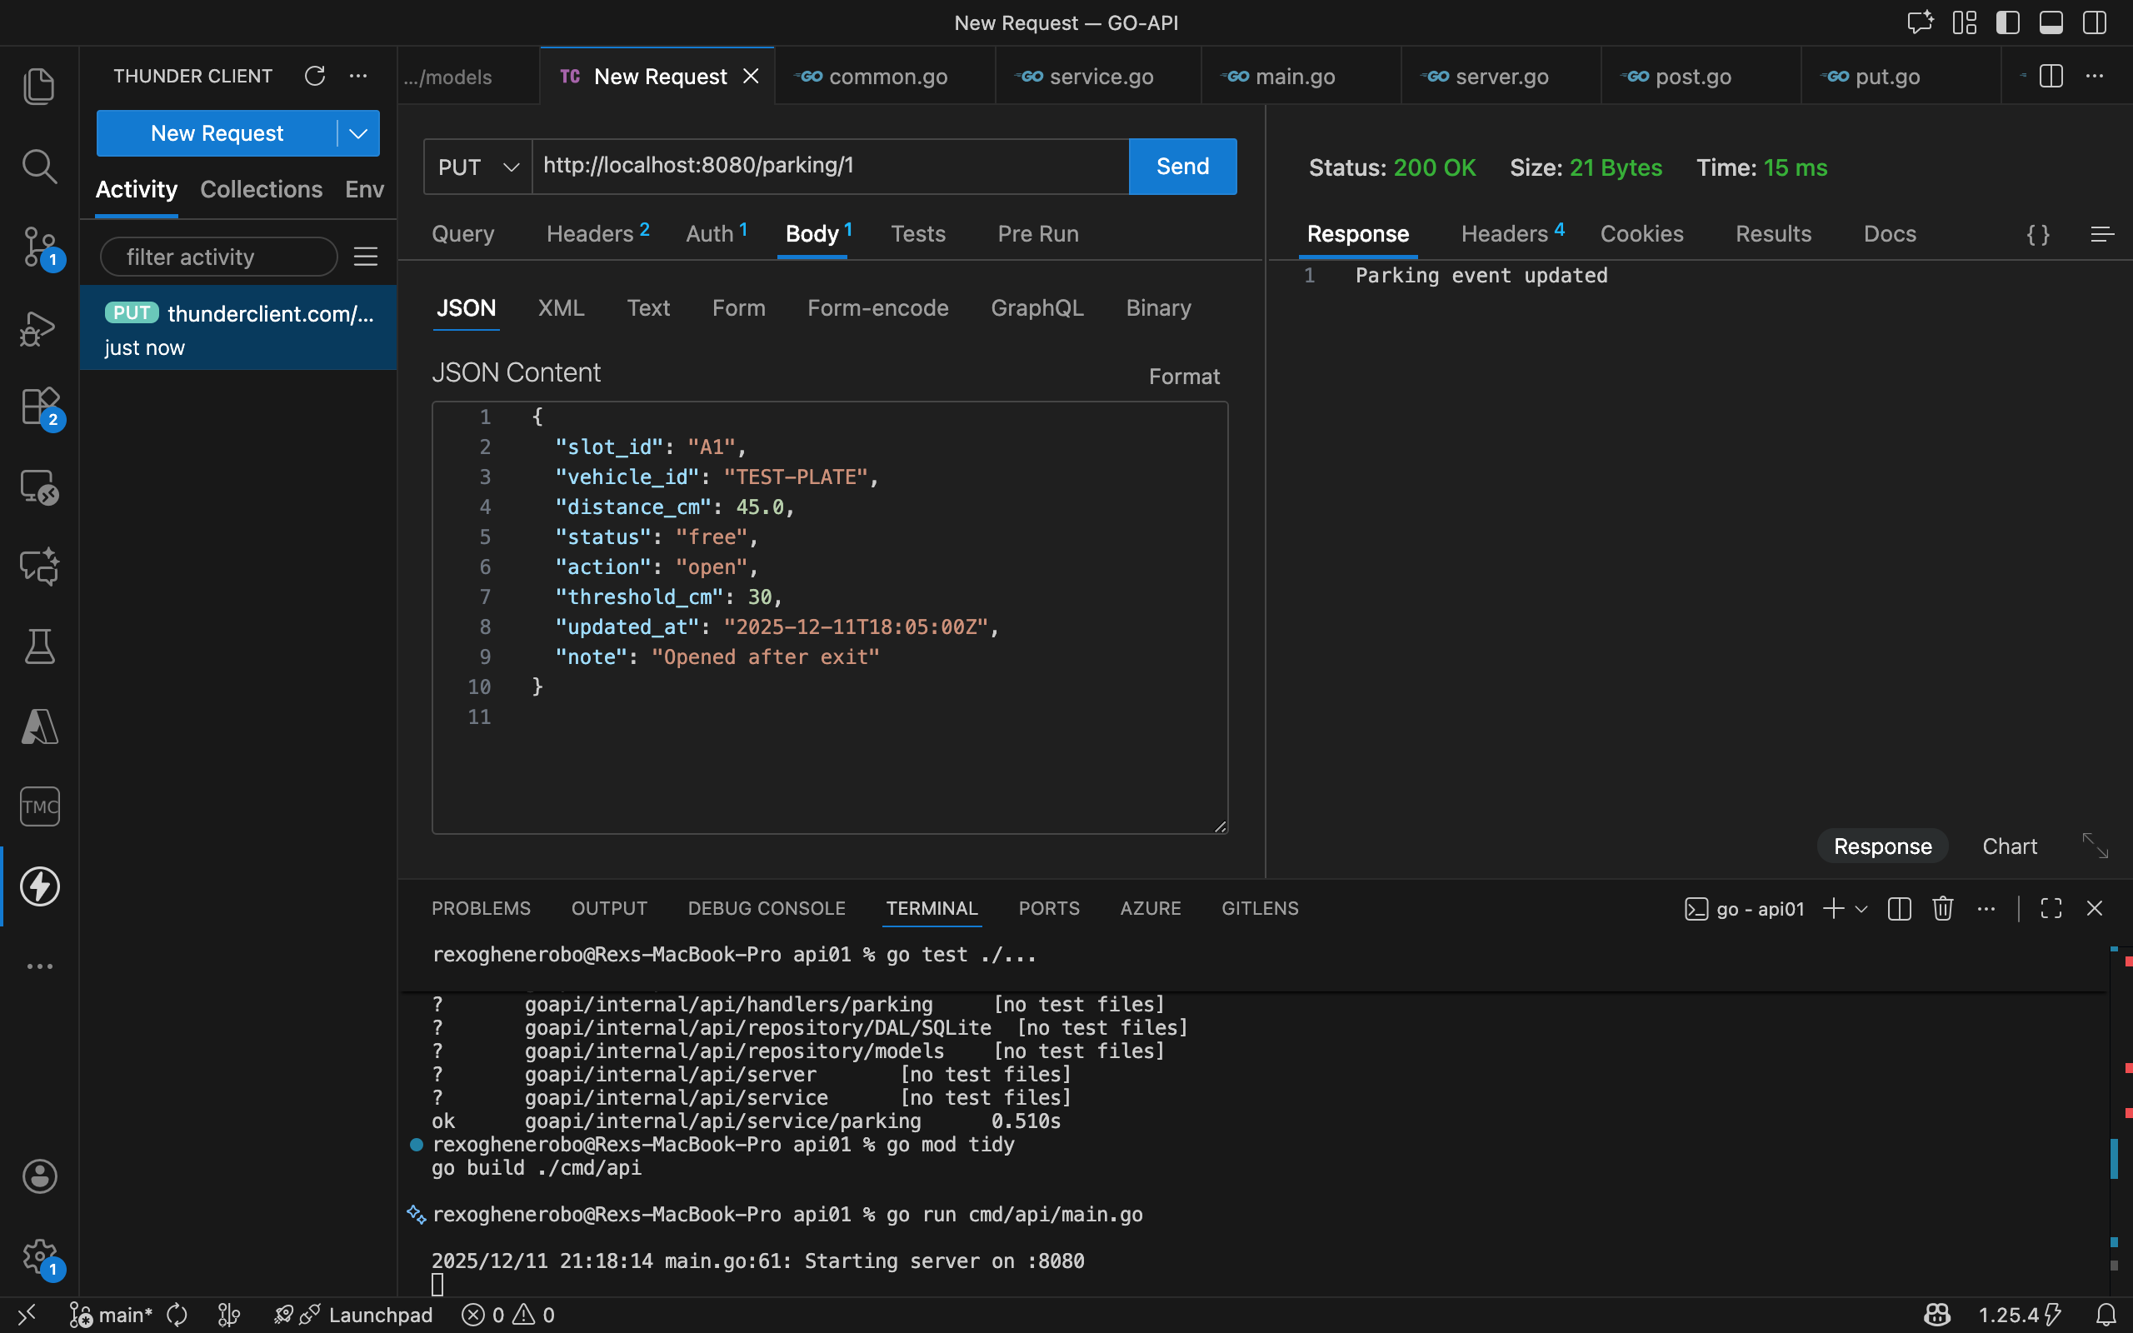

GET /parking/all — List all events
- Tested in Thunder Client
- Response: JSON array of events
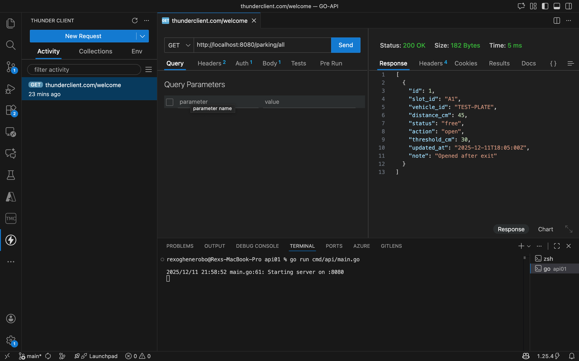

DELETE /parking/delete/1 — Delete a parking event
- Tested in Thunder Client
- Response: 200 OK
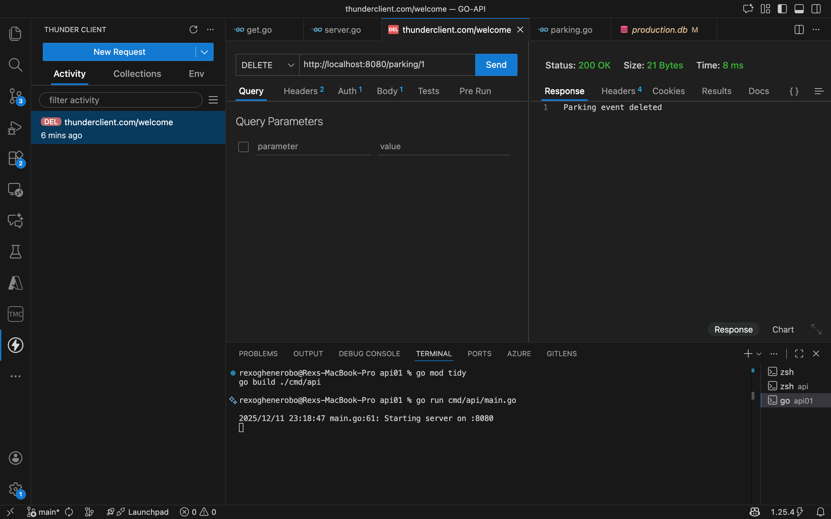

UNIT TESTING
Unit tests in service_test.go were updated to include:
- Validation of device_id and plate_number.
- Ensuring threshold_cm rejects invalid values.
- Confirming CRUD operations work with new fields.
- Command: go test ./internal/api/service/parking
- Result: All tests passed
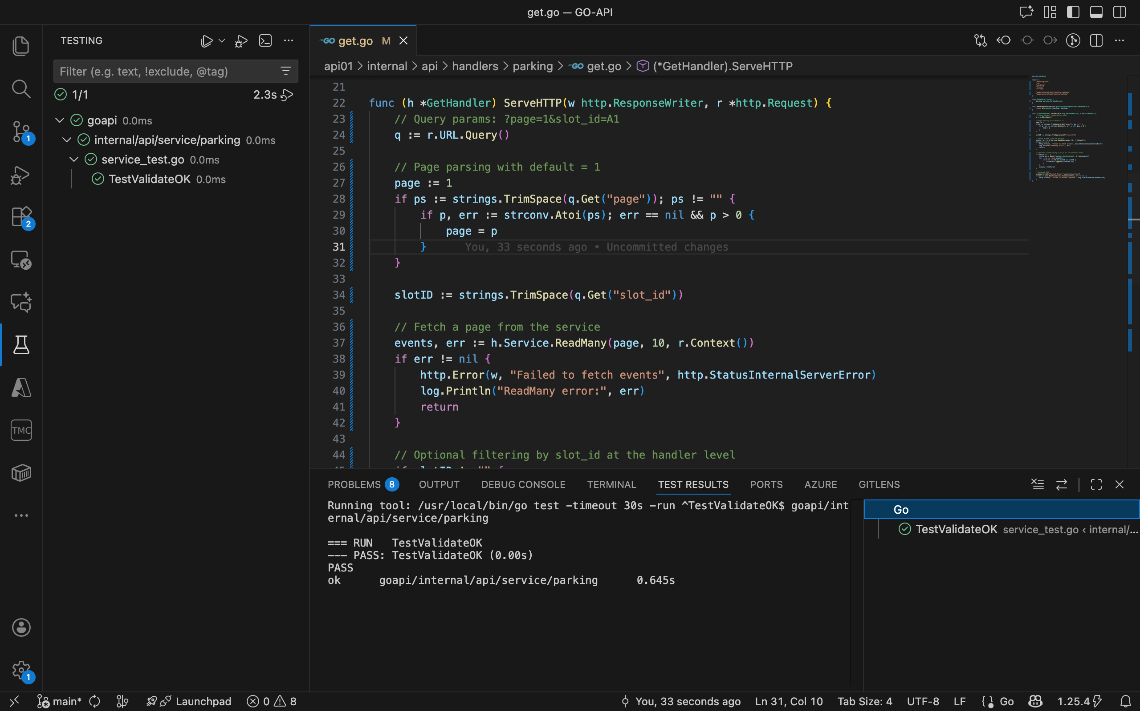

- HANDLER CUSTOMIZATION
Each handler was updated to parse and respond with the new attributes:
- POST handler: Accepts device_id, device_name, and plate_number in JSON payload.
- PUT handler: Updates these fields when modifying an event.
- GET handler: Returns the new fields in JSON responses.
- DELETE handler: Unchanged, but now deletes rows with extended schema.

- HANDLER CUSTOMIZATION
Each handler was updated to parse and respond with the new attributes:
- POST handler: Accepts device_id, device_name, and plate_number in JSON payload.
- PUT handler: Updates these fields when modifying an event.
- GET handler: Returns the new fields in JSON responses.
- DELETE handler: Unchanged, but now deletes rows with extended schema.

DATABASE VERIFICATION
- Opened production.db in VS Code using SQLite Viewer
- Browsed parking_events table
- Verified inserted and updated rows
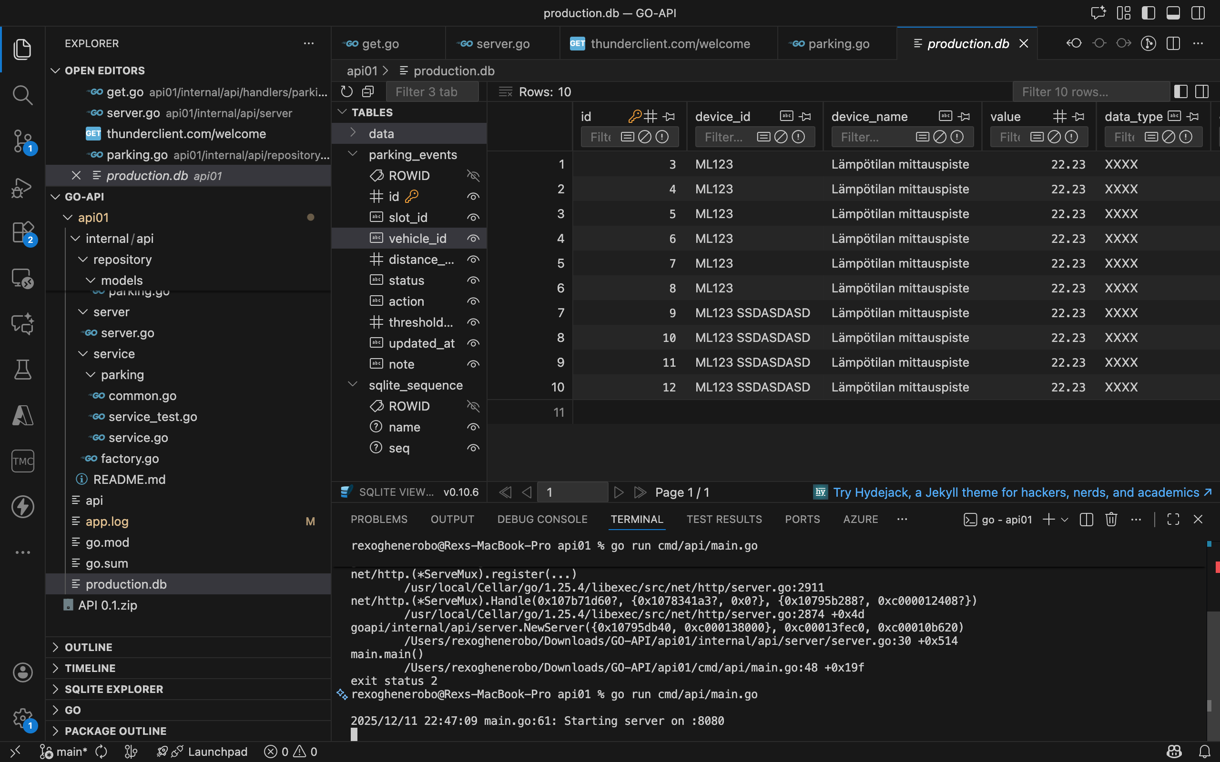

CONCLUSION
All required features were implemented and tested successfully:
- RESTful API with full CRUD
- Authentication and validation
- Unit testing
- Persistent storage in SQLite
- Visual confirmation via Thunder Client and SQLite Viewer
This report includes screenshots of each tested endpoint and database verification to support the submission.

